EXPERIMENT NO.: 13
TITLE: Prioritizing Online Learning Platform Requirements Using MoSCoW and Kano Techniques in Jira
AIM: To categorize and prioritize the requirements of an Online Learning Platform using MoSCoW and Kano techniques in Jira.
OUTPUT:
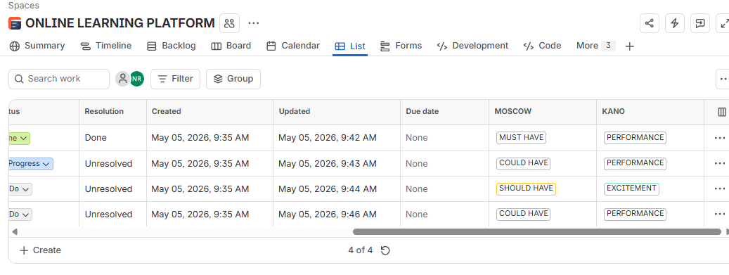
RESULT: The requirements were successfully categorized and prioritized in Jira using MoSCoW and Kano models, helping identify essential, important, and desirable features for the Online Learning Platform.

